**GITHUB AND GIT OPREATIONS**

**Done by:**

**Saravanan R**

1. To create a github local repo:

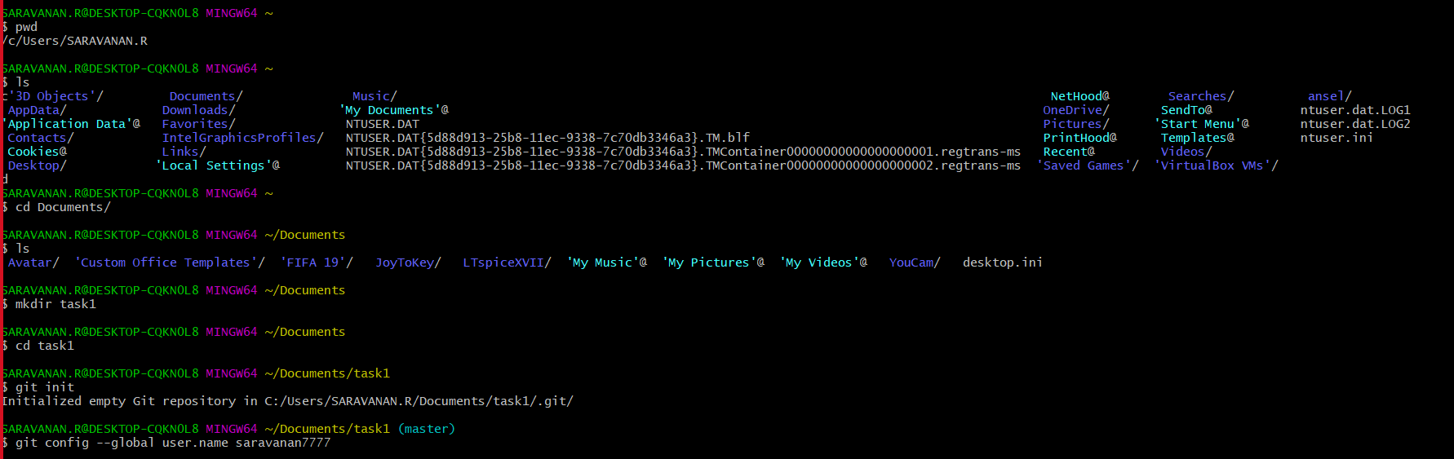

1. Git add:

It puts our file to stage.

For creating a file use touch<filename> cmd



1. Git commit:

Commit changes staged files to local branch



Git log uses to see the history of the repository

1. Git remote:

Git remote cmd is responsible for syncing changes.



1. Git branch: it is like a snapshot for your changes. Instead of copying from 1 dir to other.



1. Git push:



Git clone:

It helps to bring or copy an existing repository to a new one.



1. Git checkout:

This cmd helps you to replace all files with remote repo from a branch.



1. Git fetch:

Downloads changes from remote repo to local repo.

1. Git merge:

Merge files from given branch to current one.



1. Git pull:

Fetches changes from remote repo to local repo and merges it.

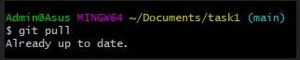

1. Git reset:

Makes the current branch point to some branch.



1. Git rebase:

It is a alternative to merge cmd.

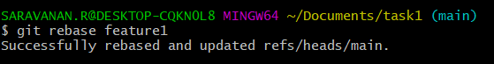

1. Git status:

Displays the current state of working directoy.

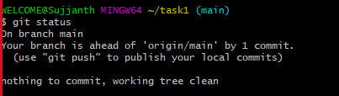

Git config –list –show-origin:

